Important Steps To Follow for College Applications

Overview
Stride Private Academy uses Naviance to submit all supporting documents to the colleges you apply to. It is important to follow these steps to ensure your documents are sent to all colleges you have applied to on time. The colleges that are listed in your Naviance account show us which colleges you have applied to and what documents need to be sent.
It is important to add all colleges you are applying to even if your application is not submitted yet.
Steps for College Application Process
- Create a Common App account and view the essay questions for the upcoming college applications.
  - https://www.commonapp.org/
  - Match your common app account with Naviance – Steps to match your account can be found here:
  - https://www.naviance.com/resources/entry/how-to-match-your-common-app-and-naviance-accounts
  - Remember to sign the FERPA agreement before matching your accounts. Here is where to find that document within your Common App account:
https://recsupport.commonapp.org/recommendersupport/s/article/Where-do-my-students-sign-their-FERPA-if-our-school-uses-Naviance
  - Start writing your essays the summer before your Senior begins if possible
- Visit the admissions pages of the colleges you are interested in
  - Compile a list of deadlines, GPA requirements, ACT/SAT requirements, # of letters of recommendations needed, etc...
- Think of 2 teachers in your core courses (math, science, history and English) that would write you a good letter of recommendation
  - email those teachers to ask if they are willing to write you a letter of recommendation
  - request the letters again using Naviance - see attachment
- Create a resume with any activities you are or have been involved in, awards, clubs, leadership positions, volunteer work, interning experience, etc.
  - This well help with your applications as well as help teachers write you a successful letter
- Use this Senior Packet to keep your organized with where you are in the process:
https://documentcloud.adobe.com/link/review?uri=urn:aaid:scds:US:11230e53-b4cc-45fc-9f56-4ee9845b2723

To Access Naviance Student
- Use this link: https://student.naviance.com/k12ia
- Username and Password are the same login credentials students use to access their courses-
*Contact Ms. Reynolds at lireynolds@strideprivateacademy.org if you need your password reset
- Remember, you will need to Match your Common Application to your Naviance account.

Accessing the List
- From Naviance Student, Colleges > Colleges I’m Applying To.
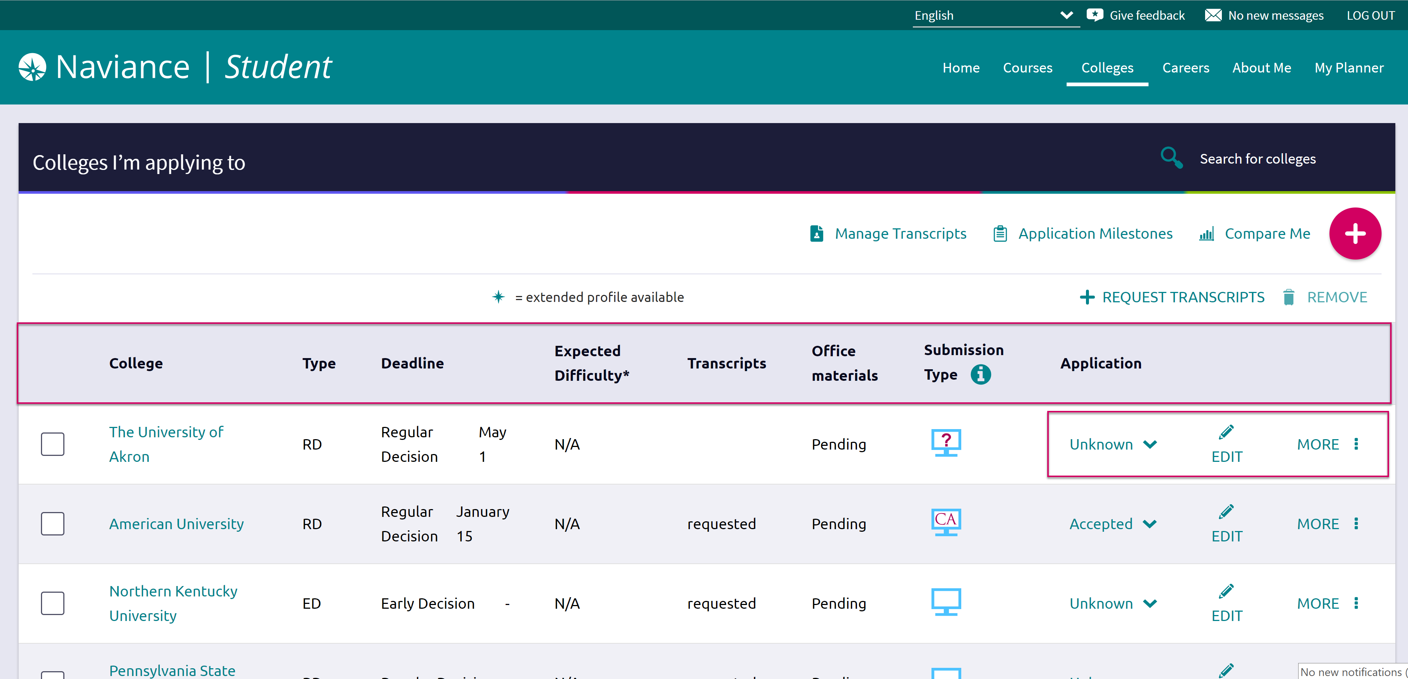

Adding a College(s) to the List & Requesting Transcripts
Colleges can be added to the Colleges I’m Applying To list in two different ways:
- From the Colleges I’m Applying To list
- From the Colleges I’m Thinking About list

From Colleges I’m Applying To
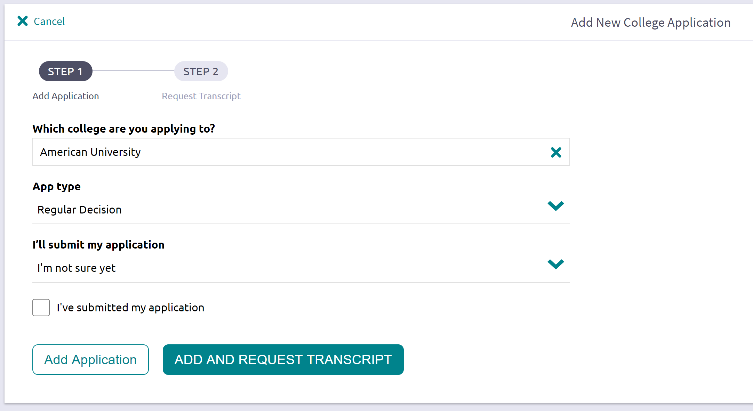
- Click the Add button (+ sign).
The Add New College Application, Step 1 Add Application displays.
- From Which college are you applying to? use the drop-down or type the name of the desired college and select from the matches.
- From App Type click the drop-down to identify your answer.
- From I’ll submit my application? click the drop-down to identify your answer.
- If you have already sent in your application, select the checkbox labeled I’ve submitted my application. If not, leave it unchecked.

To Request a Transcript:
- Please visit the link below to request a transcript from K12- this only needs to be done if you need a transcript after graduation. Please see below for further information.
- If you have attended any other schools, you will have to contact them and have them send an official transcript to the colleges you are applying to.
  - https://www.parchment.com/u/registration/414347/account
  - Ms. Reynolds will upload your initial transcript (9th-11th grade) mid year transcript (including your first semester of senior year) and final transcript (transcript showing all credits earned 9th-12th grade) for you to Naviance. It is your responsibility to confirm with Ms. Reynolds your transcript/s have been uploaded and sent to the colleges on your choice.

Letters of Recommendation
Request new and keep track of letter of recommendation requests from Colleges > Apply to College > Letters of Recommendation.
When adding a request, select a teacher to write the recommendation, a specific or all colleges from your Colleges I’m Applying To list, and any notes to share with your teacher.
- Letters of recommendation should be requested a month in advance of your college application deadlines​- the general rule is to request LOR 4-6 weeks before they are due
- Transcripts can be requested as soon as you submit your application to the college, or a week before the deadline​- remember to confirm with Ms. Reynolds your transcript status and upload to Naviance
- SAT and ACT test scores take 1-2 weeks to send. They are requested directly from the testing company and sent to the college, it is a senior responsibility to request test scores directly from the ACT website or College Board website.

Counselor Letters of Recommendation
Ms. Reynolds is your counselor. Please contact her at lireynolds@istrideprivateacademy.org if your college application/s require a counselor letter of recommendation. You will need to fill out a senior questionnaire for her to write you a successful letter.

Common App Matching – IMPORTANT
- If you are applying using the common application, you must match your accounts in Naviance. Please see the video below on how to match your accounts:
  - https://www.naviance.com/resources/entry/how-to-match-your-common-app-and-naviance-accounts

